End-to-End Autism Spectrum Disorder Detection from Gait Videos Using Markerless Pose Estimation and Machine Learning

By Prashanna Raj Pandit, Bachelor of Engineeering

A Thesis Submitted in Partial
Fulfillment of the Requirements
for the Degree of
Master of Science
in the field of Computer Science

Advisory Committee:
Sinan Onal, PhD, Chair
Mark McKenny, PhD
Manas Das, PhD

Graduate School
Southern Illinois University Edwardsville
May 2026

ABSTRACT

END-TO-END AUTISM SPECTRUM DISORDER DETECTION FROM GAIT VIDEOS
USING MARKERLESS POSE ESTIMATION AND MACHINE LEARNING

by

Prashanna Raj Pandit

Chairperson: Professor Dr. Sinan Onal

Autism Spectrum Disorder (ASD) is a neurodevelopmental condition whose early identification is linked to better outcomes when evidence-based interventions begin during childhood. Despite this, diagnostic evaluation remains time-intensive and requires specialized clinical expertise that is not always accessible. This thesis investigates an objective, video-based screening approach that analyzes how a person walks using markerless pose estimation and machine learning.

The proposed system converts ordinary walking videos into structured gait data through 2D pose estimation using OpenPose and MediaPipe. Keypoint trajectories are processed through interpolation to handle missing detections, segmented into gait cycles, resampled to a fixed temporal resolution, and smoothed using a Savitzky-Golay filter. From these standardized sequences, biomechanical gait features are computed, including lower-limb joint angles at the hip, knee, and ankle, foot orientation metrics, and lateral stability indicators. These features are modeled using classical machine learning baselines and deep sequence models, including CNN-LSTM and Bidirectional LSTM architectures, with performance evaluated through imbalance-aware metrics such as F1-score, balanced accuracy, sensitivity, specificity, and ROC-AUC.

Prior research supports the feasibility of markerless gait analysis for ASD-related motor differences, with recent work reporting classification accuracy around 0.82 using statistically selected gait parameters and logistic regression (Ganai et al., 2025). The primary contribution of this thesis is a reproducible, end-to-end pipeline that preserves temporal gait dynamics and evaluates sequence models under rigorous nested cross-validation to reduce evaluation bias.

TABLE OF CONTENTS
ABSTRACT ii
LIST OF FIGURES vi
LIST OF TABLES vii
1 CHAPTER ONE viii
INTRODUCTION viii
2 CHAPTER TWO 12
LITERATURE REVIEW 12
2.1 Autism Spectrum Disorder: Background and Prevalence 12
2.2 Diagnostic Criteria and Common Assessment Tools 13
2.3 Machine Learning Approaches for ASD Detection 14
2.4 Behavioral, Eye-Tracking, and Gait-Based Methods 15
2.5 Datasets Used in Prior Work 16
2.6 Comparison of Methods, Strengths, Weaknesses, and Gaps 17
2.7 Summary and Motivation for the Proposed Method 18
3 CHAPTER THREE 20
METHODOLOGY 20
3.1 Data Collection and Participant Characteristics 20
3.2 Pose Estimation and Keypoint Extraction 23
3.3 Preprocessing: Handling Missing and Noisy Keypoints 23
3.4 Biomechanical Feature Extraction 24
3.5 Gait Cycle Segmentation and Temporal Standardization 27
3.6 Normalization 31
3.7 Modeling Approaches and Architectures 32
3.7.1 Feature Engineering for Traditional Machine Learning 32
3.7.2 Feature Selection 32
3.7.3 Traditional Machine Learning Models 33
3.7.4 Deep Learning Model: Bidirectional LSTM with Optuna Hyperparameter Tuning 34
3.8 Training, Validation, and Imbalance Handling 36
3.9 Evaluation Metrics 37
4 CHAPTER FOUR 38
RESULTS 38
4.1 Feature Analysis and Selection 38
4.2 Traditional Machine Learning Results 39
4.3 Cross-Validation Stability of Traditional Models 40
4.4 Deep Learning Model: Bidirectional LSTM with Optuna Tuning 41
4.5 Feature Discriminability Analysis 42
5 CHAPTER FIVE 44
DISCUSSION 44
5.1 Interpretation of Results 44
5.2 Model Comparison and Practical Implications 45
5.3 Methodological Strengths 46
5.4 Limitations and Threats to Validity 46
6 CHAPTER SIX 48

LIST OF FIGURES

Figure 1: Lab setup for side view video recording. 21
Figure 2: Lab setup for the front view video recording. 22
Figure 3: Data processing and feature extraction pipeline. 22
Figure 4:Figure X: Geometric angle computation used in this study. (a) Side View: Sagittal plane kinematics showing hip, knee, and ankle flexion/extension, and Dorsiflexion/Plantarflexion. (b) and (c) shows the front view angles: Hip adbuction/adduction and Kne abduction/adduction. In all diagrams, solid arrow lines represent anatomical vectors derived from joint centers, dashed vertical arrows indicate the reference vectors, and dashed arcs denote the calculated angular displacement ϴ. 24
Figure 5: Turn detection in front view videos. 28
Figure 6: Turn detection in the side view videos. 28
Figure 7: Violin plot distribution of frame counts (a) per gait cycle and (b) four gait cycles in both front and side videos. 29
Figure 8:Smoothing of raw gait time-series features using a Savitzky-Golay (SavGol) filter. 31
Figure 9:Bar chart comparing accuracy, sensitivity, specificity, F1-score, and AUC across the three traditional machine learning models on the held-out test set. 39
Figure 10: ROC curves for all three models on the test set. The dashed diagonal represents chance-level discrimination. The SVM curve lies above both baselines across the full operating range, reflecting an AUC of 0.935. 40
Figure 11: Cross-validation AUC distributions across 15 resampling folds. Points show the median; horizontal bars show the 95% confidence interval. All three models show wide ranges consistent with small training set size. 41

LIST OF TABLES

Table 1: Distribution of Dataset by Demographic and Recording Characterstics (N=74) 21
Table 2: Statistically Significant Gait Features: ASD versus Non-ASD (p < 0.05) 39
Table 3: Test-Set Performance of Traditional Machine Learning Models 39
Table 4: Bidirectional LSTM Performance on Hold-Out Test Set (Seed 16, Optuna-Tuned) 42

CHAPTER ONE

INTRODUCTION

Autism Spectrum Disorder (ASD) is a neurodevelopmental condition characterized by persistent differences in social communication and interaction, alongside restricted and repetitive patterns of behavior. The clinical presentation varies widely across individuals, ranging from minimal support needs to significant daily-life challenges in language, learning, and adaptive functioning (Centers for Disease Control and Prevention [CDC], 2025a). According to the most recent surveillance data from the Autism and Developmental Disabilities Monitoring Network, approximately 1 in 36 children in the United States has been identified with ASD, reflecting a substantial increase in prevalence over the past two decades (CDC, 2023).

Early identification of ASD matters because timely intervention is associated with better outcomes in communication skills, social functioning, and long-term independence (National Institute of Child Health and Human Development [NICHD], 2021). Current diagnostic evaluation relies on structured caregiver interviews, standardized observational protocols, and professional clinical judgment, following criteria established in the Diagnostic and Statistical Manual of Mental Disorders, Fifth Edition (DSM-5) (American Psychiatric Association, 2022). While these evaluations remain the clinical gold standard, they are time-consuming, require specialist expertise, and are frequently subject to long waiting lists that delay access to services for many families.

This has motivated sustained research interest in objective, scalable behavioral markers that could support earlier screening and triage for full clinical evaluation.

Motor behavior and gait have emerged as particularly attractive candidates because walking is a natural activity, can be recorded unobtrusively with consumer-grade cameras, and is supported by an established biomechanical literature in ASD research. Several studies have documented consistent gait differences in children with ASD compared to typically developing peers, including increased step width, altered stride and step lengths, and differences in joint range of motion at the ankle, knee, and hip (Kindregan et al., 2015).

More recent work has begun using markerless pose estimation on standard video recordings to extract gait parameters and train machine learning classifiers. A 2025 study published in Scientific Reports used MediaPipe-based pose estimation and reported that logistic regression achieved approximately 0.82 accuracy when classifying children with ASD versus typically developing children using statistically selected gait parameters (Ganai et al., 2025). This result motivates the exploration of gait as a potential behavioral biomarker in accessible, non-laboratory settings.

The objective of this thesis is not to replace clinical diagnosis. The goal is to develop and evaluate a reproducible, end-to-end pipeline that can support screening assistance or research exploration by linking gait video signals to ASD classification under careful, rigorous validation. The system processes ordinary walking videos through markerless pose estimation, extracts biomechanical gait features, and trains both classical machine learning models and deep sequence models to distinguish ASD from typically developing gait patterns.

Problem Statement
Conventional ASD evaluation is resource-intensive and frequently subject to delays. A complementary, objective screening-support pipeline using gait videos could improve accessibility and scalability, provided it is methodologically rigorous and accompanied by appropriate limitations and ethical framing.

Research Objectives
- Build a reproducible pipeline that converts gait videos into pose keypoints and standardized gait cycle sequences.
- Engineer interpretable gait features from pose trajectories, focusing on lower-limb joint angles and bilateral symmetry indicators.
- Evaluate both classical machine learning models and temporal deep learning models on these features.
- Quantify performance using imbalance-aware metrics and rigorous cross-validation strategies.
- Document limitations, reproducibility considerations, and ethical issues relevant to clinical deployment.

CHAPTER TWO

LITERATURE REVIEW

Autism Spectrum Disorder: Background and Prevalence
Autism Spectrum Disorder is a neurodevelopmental condition characterized by persistent difficulties in social communication and interaction, together with restricted and repetitive patterns of behavior, interests, or activities. Individuals on the spectrum can show differences in eye contact, facial expressions, gestures, and movement from early childhood, and these differences often affect social, academic, and daily functioning in significant ways (CDC, 2025a; Autism Speaks, 2025).

Early and accurate identification is important because timely intervention is associated with better outcomes in communication, adaptive skills, and long-term independence (NICHD, 2021). The prevalence of ASD has increased substantially in recent decades, from approximately 1 in 150 children in the early 2000s to 1 in 36 children as of 2020, based on data from the CDC's Autism and Developmental Disabilities Monitoring Network (CDC, 2023). This increase reflects a combination of broadened diagnostic criteria, improved identification practices, and possible environmental factors, though the full picture remains an active area of research.

Current diagnostic practice follows the DSM-5 criteria, which define ASD in terms of two behavioral domains: persistent deficits in social communication and interaction across multiple contexts, and restricted, repetitive patterns of behavior, interests, or activities that must be present from early developmental periods and cause clinically significant impairment (American Psychiatric Association, 2022). Multidisciplinary teams typically combine caregiver history, developmental information, and structured observations to reach a diagnosis. Although considered the gold standard, these evaluations are time-consuming, require specialist expertise, and often involve waiting periods that delay access to services.

Diagnostic Criteria and Common Assessment Tools
Clinicians commonly use structured observation tools and caregiver-report questionnaires to gather systematic information about ASD-related behaviors. Widely used instruments include the Autism Diagnostic Observation Schedule (ADOS-2), which provides a standardized semi-structured observation of social and communicative behavior, and the Autism Diagnostic Interview-Revised (ADI-R), a structured parent interview. Additional screening tools such as the Modified Checklist for Autism in Toddlers (M-CHAT) are used in primary care settings for early identification in toddlers (Autism Speaks, 2025).

These instruments improve reliability across raters but still depend substantially on human judgment and can be influenced by rater training, cultural context, and the specific setting in which the assessment takes place. As a result, there is growing interest in objective, data-driven markers that can be captured non-invasively and quantified using computational methods. Motor behavior and gait are among the most accessible of these markers, given that walking can be recorded with ordinary video cameras without requiring physical contact or specialized equipment (Wolff et al., 2012).

Machine Learning Approaches for ASD Detection
A substantial body of work now uses machine learning to assist with ASD detection and screening. Early studies mainly focused on tabular data derived from diagnostic questionnaires and behavioral ratings, where responses are converted into numerical features and used to train classifiers such as logistic regression, support vector machines, decision trees, random forests, or gradient boosting algorithms (Thabtah et al., 2019). These models can achieve reasonable accuracy and are relatively interpretable, particularly when feature importance analyses are used to identify which questionnaire items contribute most to classification.

With greater availability of multimodal data, more recent studies have moved beyond questionnaire-based inputs to incorporate images, video, audio, and physiological signals. Deep learning architectures, including convolutional neural networks, recurrent networks, and attention-enhanced hybrids, have been applied to facial images, social interaction videos, and brain imaging data to learn complex patterns associated with ASD without relying on handcrafted features (Yassin et al., 2021). These approaches can capture non-linear relationships in high-dimensional data but typically require large labeled datasets and careful regularization to avoid overfitting, which is a persistent challenge in ASD research where sample sizes are often limited.

One important line of research uses machine learning on short home or clinical videos. In these studies, parents or clinicians record structured or semi-structured interactions, and automated models analyze the videos to estimate ASD likelihood. Some works combine automatically extracted behavioral features, such as gaze direction, affect, and response latency, with questionnaire information to build ensemble classifiers (Abbas et al., 2023). While promising, these video-based approaches face challenges related to data quality, environmental variability, and the need for sufficiently large and demographically diverse training datasets.

Behavioral, Eye-Tracking, and Gait-Based Methods
Beyond questionnaires and neuroimaging, a growing number of studies focus on observable motor behavior, particularly eye movements, posture, and gait. Eye-tracking research examines where and how long individuals look at regions of a visual scene. Several studies report that children with ASD spend less time looking at faces or eyes and more time on non-social objects and scene backgrounds. Machine learning models trained on gaze features have been shown to distinguish ASD from non-ASD groups with reasonable accuracy (Chita-Tegmark, 2016).

Video-based behavioral analysis records naturalistic or structured social interactions and applies computer vision to extract body pose, facial expressions, and movement trajectories. For example, some studies use 2D pose estimation to track body joints over time and quantify how children move or gesture during play tasks, then feed these features into classifiers that differentiate ASD from typical development (Zunino et al., 2018).

Gait analysis is particularly central to this thesis. Clinical and biomechanical research consistently reports that children with ASD show a range of gait differences compared to typically developing peers, including reduced stride length, increased step width, a wider base of support, longer stance phases, and reduced ankle and knee range of motion, sometimes accompanied by increased hip flexion (Kindregan et al., 2015; Mache & Todd, 2016). These patterns are thought to reflect a more rigid or stabilizing gait strategy, possibly related to differences in balance, proprioception, or motor planning. From a computational standpoint, gait studies typically collect motion-capture or video data as participants walk along a fixed path, extract kinematic and spatiotemporal features, and train machine learning models to classify ASD versus control groups. A recent markerless approach using MediaPipe-based pose estimation demonstrated that logistic regression trained on statistically significant gait parameters could achieve approximately 0.82 accuracy in classifying ASD versus typically developing children (Ganai et al., 2025).

Datasets Used in Prior Work
ASD machine learning studies use heterogeneous datasets that differ considerably in size, modality, and labeling strategy. Questionnaire-based works typically rely on curated datasets containing responses to standardized screening or diagnostic tools alongside clinical labels. These can be relatively large and convenient to analyze but primarily reflect rater judgments rather than raw behavioral observations (Thabtah et al., 2019).

Video- and sensor-based studies generally rely on smaller, custom-collected datasets. Gait-focused work in particular often has only a few dozen ASD participants and a comparable number of typically developing controls, because experiments require controlled recording conditions, in-person participation, and careful clinical labeling (Kindregan et al., 2015; Mache & Todd, 2016). These datasets are rich in kinematic detail but present significant challenges for deep learning models that require large sample sizes to generalize reliably.

In this thesis, the dataset comprises gait videos from 74 participants, 30 with ASD and 44 typically developing, each recorded from both front and side views while walking a standardized path. The analysis focuses on lower-body gait features extracted from both views, including joint angle trajectories and bilateral motion characteristics, which are well-supported by prior findings on ASD-related gait deviations (Kindregan et al., 2015).

Comparison of Methods, Strengths, Weaknesses, and Gaps
Each methodological approach in the ASD detection literature has distinct strengths and limitations. Questionnaire-based machine learning models are practical, relatively easy to implement, and can perform well on modest datasets. However, they depend on subjective caregiver or clinician reports, which may be influenced by cultural context, rater familiarity with ASD, and the specific items used in a given tool. They also do not directly observe behavior, which limits the discovery of new objective markers.

Deep learning on images, videos, and neuroimaging can learn complex high-dimensional patterns and achieve strong performance when trained on large, well-labeled datasets. In the ASD context, however, small sample sizes increase the risk of overfitting and limit generalizability to new populations and recording conditions (Yassin et al., 2021). These models are also often difficult to interpret, which can limit clinician trust in their outputs.

Gait-based methods offer a middle ground by leveraging objective, observable motor characteristics using relatively accessible hardware. Motion capture and video-based gait studies consistently report differences in stride length, step width, joint range of motion, and movement variability between ASD and control groups (Kindregan et al., 2015; Mache & Todd, 2016; Ganai et al., 2025). A key limitation is that these studies typically involve small samples, which increases overfitting risk, and many report only overall accuracy without examining which specific gait features drive classification.

A further gap in the literature is methodological heterogeneity. Studies differ in camera placement, walking distance and instructions, feature extraction approaches, and outcome definitions, making direct comparisons across studies difficult. Some use laboratory-based three-dimensional motion capture systems, while others rely on markerless two-dimensional pose estimation from standard video. There remains limited work that systematically evaluates lower-body gait features from both sagittal and frontal views using markerless video for ASD detection with machine learning on realistically small clinical datasets.

Summary and Motivation for the Proposed Method
The literature demonstrates that machine learning can support ASD detection using a range of data sources, from questionnaires and neuroimaging to eye-tracking and video-captured motor behavior. Questionnaire-based models are practical but tied to subjective reports. Deep learning on large multimodal datasets is powerful but constrained by data availability and interpretability. Behavioral and gait-based approaches highlight motor differences as objective markers but frequently rely on small samples, heterogeneous protocols, and limited feature interpretability analysis.

This thesis focuses on video-based gait analysis with markerless pose estimation to address several of these gaps. Using 74 participants recorded from both front and side views and concentrating on lower-body features extracted from both perspectives, the work aims to capture clinically relevant gait characteristics with a recording setup accessible to research and clinical teams without specialized equipment. The approach extracts interpretable lower-body gait features and trains multiple machine learning models that distinguish ASD from typically developing gait while explicitly accounting for the challenges of limited sample size and mild class imbalance. By clearly describing data collection, feature extraction, and evaluation procedures, and by examining which gait features most consistently influence model decisions, this work contributes a transparent and behaviorally grounded analysis to the ASD detection literature.

CHAPTER THREE

METHODOLOGY

Data Collection and Participant Characteristics
The dataset used in this thesis was collected by the Northern Illinois University research team following a standardized laboratory protocol. A total of 74 participants were recruited, comprising 30 children with a confirmed ASD diagnosis and 44 typically developing children. Each participant was recorded from two camera perspectives, a side view and a front view, during a structured walking task, producing 148 video recordings in total. The participant characteristics are summarized in Table 1.

Variable | Category | n (%) or Statistic
Total Subjects | -- | 74 (100.0%)
Clinical Status | ASD | 30 (40.5%)
 | Non-ASD | 44 (59.5%)
Age (years) | Mean (SD) | 7.51 (±2.37)
 | Median (Q1-Q3) | 7.0 (6.0-9.0)
 | Range | 3.0-12.0
Sex | Male | 49 (66.2%)
 | Female | 23 (31.1%)
 | Missing | 2 (2.7%)
Height (inches) | Mean ± SD | 50.44 ± 6.19
 | Range | 39.20-64.00
 | Missing | 5(6.8%)
Video Inventory | Side-view recordings | 74 (100.0%)
 | Front-view recordings | 74 (100.0%)

Table 1: Distribution of Dataset by Demographic and Recording Characterstics (N=74)
For the side-view recording, the walking path was set to 13 feet in length. The camera was aligned with the midpoint of the walking path, and the lens was positioned 3 feet above the ground regardless of tripod height. This standardized placement ensured consistent joint visibility throughout the walk. For the front-view recording, the walking path was marked to 11 feet. The camera was positioned 14 feet ahead of the endpoint for 1x optical zoom and 18 feet for 2x optical zoom, with the lens at the same height as the side-view setup. Each participant completed multiple passes along the walking path, walking first in one direction and then returning, to capture a sufficient number of gait cycles for analysis. The lab setup for the side and front video recording in shown in Figure 1 and Figure 2 respectively.
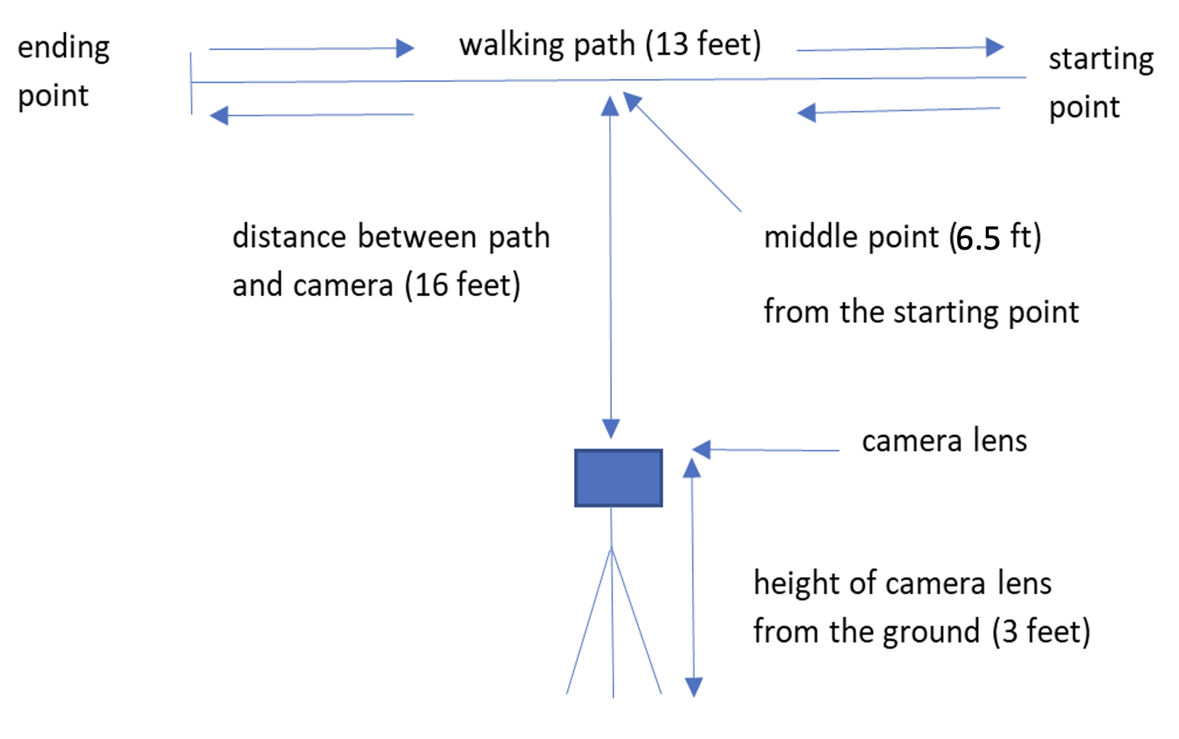
Figure 1: Lab setup for side view video recording.
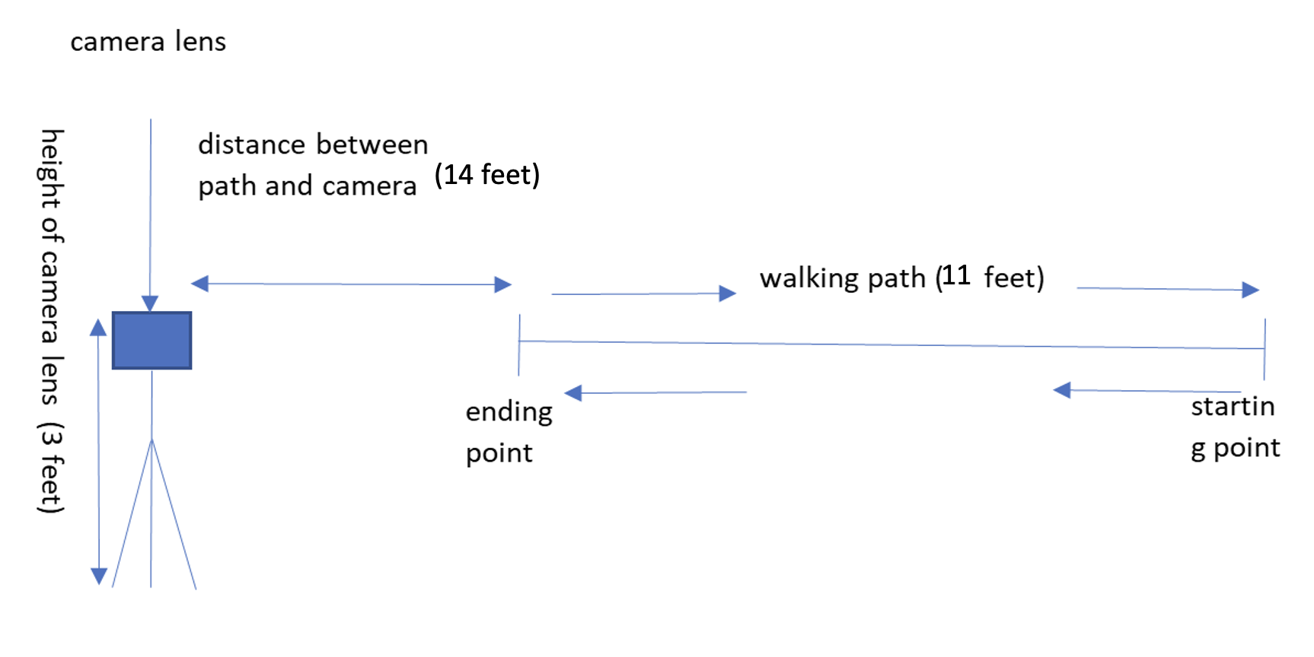
Figure 2: Lab setup for the front view video recording.
The data type consisted of RGB video recordings of subjects walking in a controlled indoor environment. Each subject was assigned a binary class label indicating ASD or non-ASD status. The unit of analysis was the individual subject, with each represented by a standardized multi-cycle gait sequence derived from the full recording.
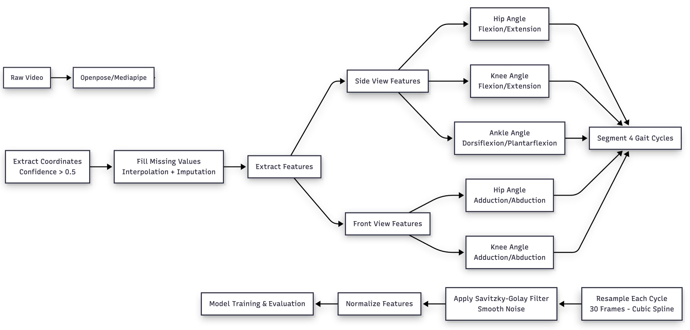
Figure 3: Data processing and feature extraction pipeline.

Pose Estimation and Keypoint Extraction
The data processing pipeline supports two pose estimation backends. The primary backend used in this work is OpenPose, a bottom-up multi-person two-dimensional keypoint detection system based on Part Affinity Fields (Cao et al., 2021). OpenPose outputs joint location coordinates and confidence scores for all detected body keypoints across each video frame, stored in a standard JSON format. MediaPipe Pose (BlazePose) was also evaluated as an alternative backend, offering a 33-landmark skeleton model optimized for single-person detection on consumer devices (Lugaresi et al., 2019).

For each subject, all frames from both the front-view and side-view recordings were parsed and converted into structured data frames. Only keypoints with a detection confidence score above 0.5 were accepted as reliable. Keypoints falling below this threshold were marked as missing values and addressed in the subsequent preprocessing stage. This confidence filtering step ensures that downstream angle computations are grounded in reliable pose estimates and are not distorted by low-quality detections.

Preprocessing: Handling Missing and Noisy Keypoints
Pose-based time series commonly exhibit missing keypoints and frame-to-frame jitter due to occlusion, clothing variation, and natural instability in the pose estimation model. The pipeline addresses these issues in two stages.

Short gaps in a keypoint's trajectory, caused by brief occlusion or momentary detection failure, are filled using linear or spline-based interpolation. This preserves continuity in the trajectory without introducing discontinuities that would distort subsequent angle calculations. For longer gaps, where a keypoint is absent across several consecutive frames, is applied using local linear models or constraints from neighboring joints. This step reduces the risk of large discontinuities entering the feature extraction stage.

Biomechanical Feature Extraction
All joint angles were computed from two-dimensional pose keypoint coordinates using a custom feature extraction pipeline. Eight sagittal-plane features were derived from the side-view recordings and four frontal-plane features from the front-view recordings. Figure X illustrates the geometric relationships underlying each computation. The formulas and landmark definitions for each feature are described below.

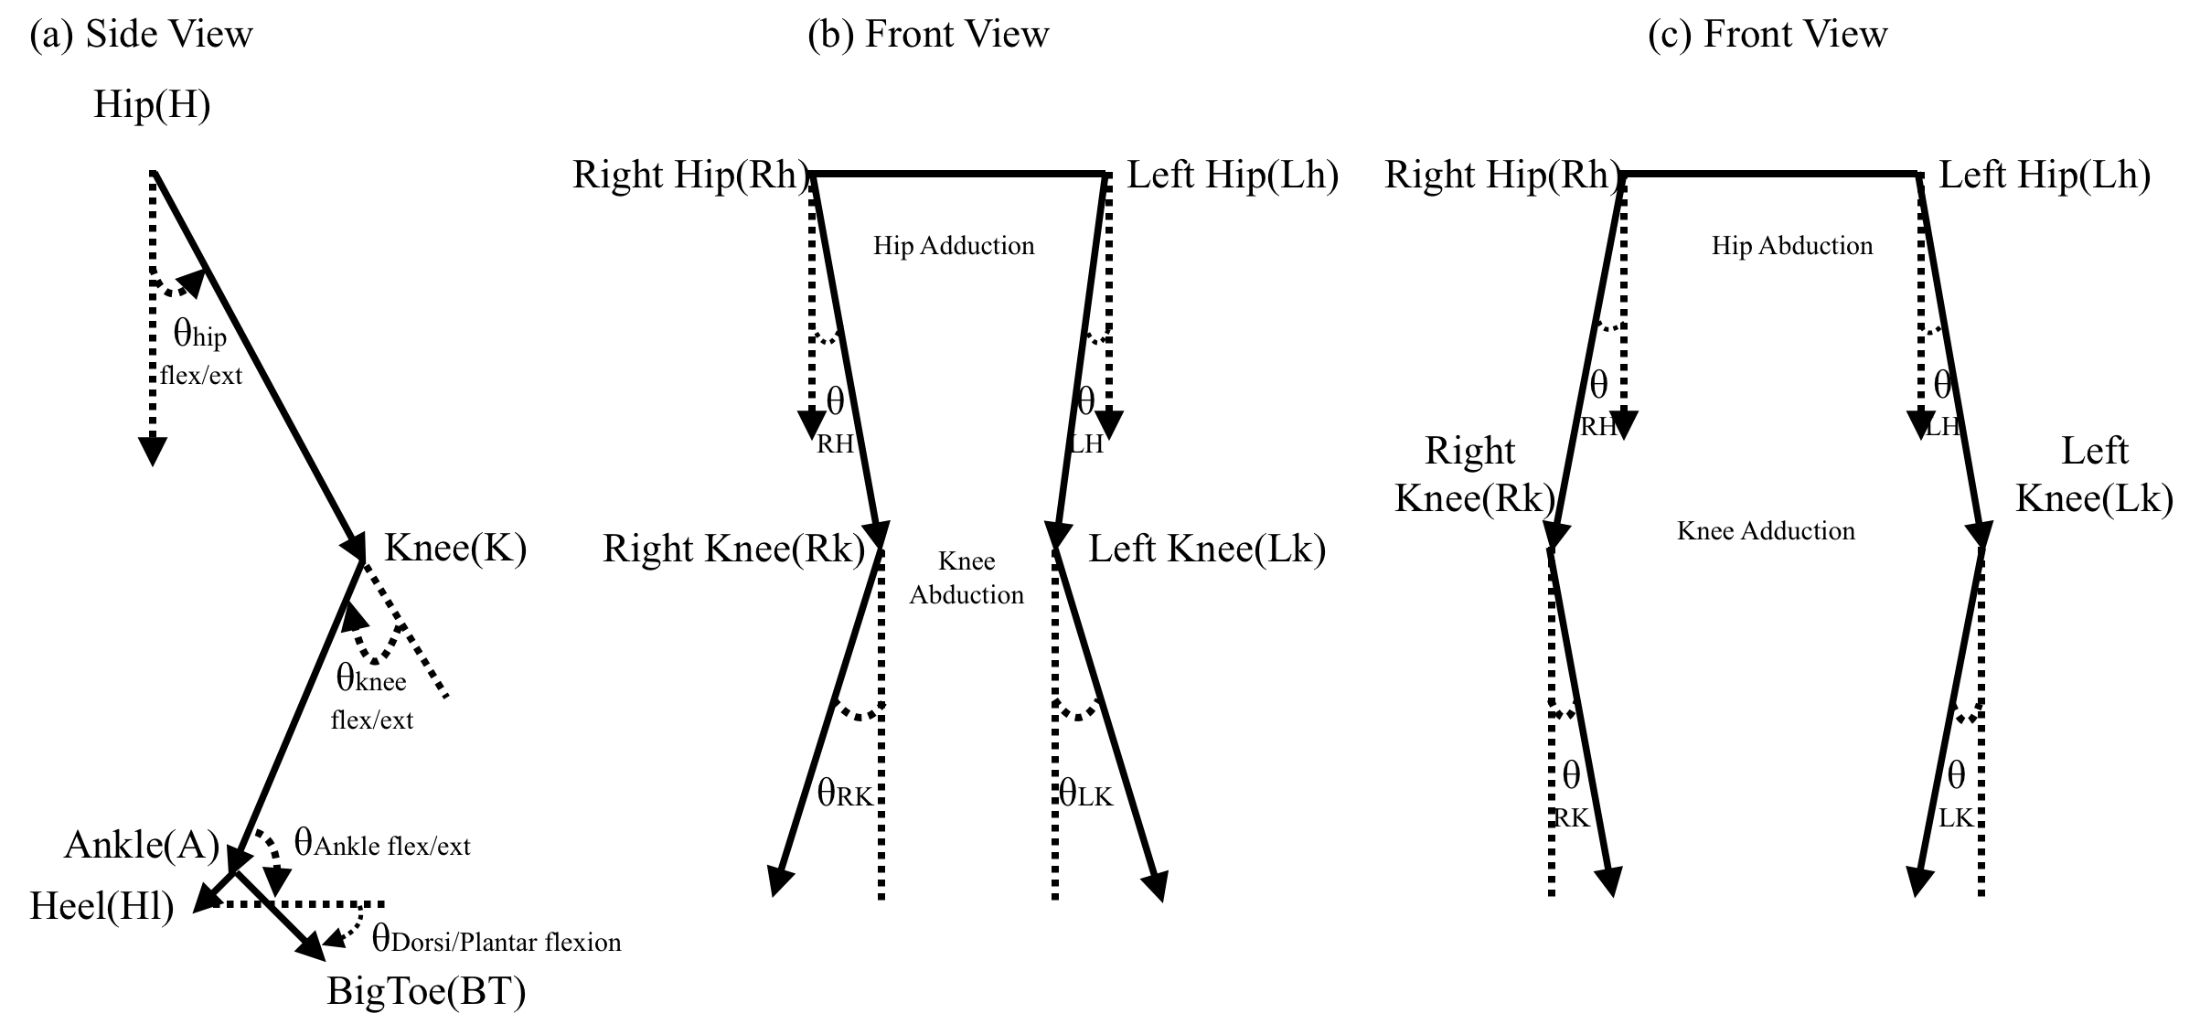
Figure 4:Figure X: Geometric angle computation used in this study. (a) Side View: Sagittal plane kinematics showing hip, knee, and ankle flexion/extension, and Dorsiflexion/Plantarflexion. (b) and (c) shows the front view angles: Hip adbuction/adduction and Kne abduction/adduction. In all diagrams, solid arrow lines represent anatomical vectors derived from joint centers, dashed vertical arrows indicate the reference vectors, and dashed arcs denote the calculated angular displacement ϴ.
Ankle Angle. Computed at the ankle vertex using the knee (K), ankle (A), and big toe (T) as the three landmarks:
θₐₙₖₗₑ = |arctan2(Tᵧ − Aᵧ, Tₓ − Aₓ) − arctan2(Kᵧ − Aᵧ, Kₓ − Aₓ)| × (180 / π)
Values exceeding 180 degrees are corrected to (360 − θ). This angle captures foot orientation relative to the lower leg and reflects push-off mechanics and foot placement patterns during walking.
Knee Flexion Angle. Computed from the hip (H), knee (K), and ankle (A) landmarks using the dot product of the thigh and shank vectors:
θₖₙₑₑ = 180 − arccos( (KH · KA) / (|KH| × |KA|) )
where KH and KA are vectors from the knee toward the hip and ankle respectively. A value of zero indicates a fully straight leg; larger values indicate increasing flexion during swing or loading phases.
Hip Flexion Angle. Computed as the angle between the hip-to-knee vector and a fixed downward vertical reference (0, −1), using the hip (H) and knee (K) landmarks:
θₕᵢₚ = 180 − arccos( HK · (0, −1) / |HK| )
where HK is the vector from the hip toward the knee. The vertical reference has unit magnitude, so the denominator reduces to |HK| alone. This angle measures how far the thigh deviates from a neutral vertical posture and is sensitive to compensatory hip strategies reported in children with ASD (Kindregan et al., 2015).
Dorsiflexion and Plantarflexion Angle. Computed as the inclination of the foot segment relative to the horizontal plane, using the heel (Hl) and big toe (T) coordinates:
θᵈᴼ = arctan( |Tᵧ − Hlᵧ| / |Tₓ − Hlₓ| )
This provides a proxy for foot orientation during push-off and clearance phases. Absolute values in both terms keep the angle positive regardless of walking direction relative to the camera.
Hip and Knee Adduction/Abduction Angles. Extracted from the front-view recordings, these four angles apply the same dot product formulation as the sagittal-plane features but to frontal-plane coordinates. The hip angle uses the hip-to-knee vector against the vertical reference; the knee angle uses the thigh and shank vectors at the knee joint. Because single-camera two-dimensional recordings do not provide depth information, signed adduction versus abduction could not be reliably determined, so both angles are retained as unsigned magnitudes. These features are sensitive to lateral sway and pelvic stability during walking, characteristics that have been found to differ between children with ASD and typically developing peers (Mache & Todd, 2016).
All features were computed independently for the right and left sides of the body. Table 2 summarizes the full feature set with the landmarks used for each computation.

θ = arccos( BA · BC / (|BA| |BC|) )
Table 2 provides a complete summary of all twelve gait features used in this study.
Knee angle = 180 − arccos( (KH · KA) / (|KH| × |KA|) )
where KH is the vector from the knee to the hip and KA is the vector from the knee to the ankle.
Hip angle = 180 − arccos( HK · (0, −1) / (|HK| × 1) )
where HK is the vector pointing from the hip toward the knee, and (0, -1) is the unit vector pointing straight downward in the image coordinate system. Because the magnitude of the vertical reference is always 1, the denominator simplifies to the magnitude of HK alone.
Dorsi/Plantar angle = arctan( |Tᵧ − Hlᵧ| / |Tₓ − Hlₓ| )
where the numerator is the vertical pixel difference between the toe and heel, and the denominator is the horizontal pixel difference. The absolute value in both terms ensures the angle is always positive regardless of walking direction relative to the camera.

Gait Cycle Segmentation and Temporal Standardization
Gait cycles vary across subjects due to differences in walking speed, stride length, and recording conditions. To produce comparable sequences across all participants, the pipeline applies a standardized segmentation and resampling procedure.

Before gait cycle detection, turning phases are removed from each recording. Turning segments introduce irregular motion patterns and frequently produce missing or unreliable keypoints, which would distort cycle detection and downstream analysis. For front-view recordings, turning is identified by analyzing the horizontal displacement of the left and right shoulder keypoints relative to the neck. The shoulder signals are first smoothed using a Savitzky-Golay filter to reduce noise while preserving motion trends. Abrupt transitions and sign changes in these signals correspond to directional changes in upper body orientation and are flagged as turning events as shown in figure 3. For side-view recordings, turning is identified by computing the inter-shoulder distance and examining its smoothed signal for prominent peaks that indicate subject rotation relative to the camera as shown in figure 4.
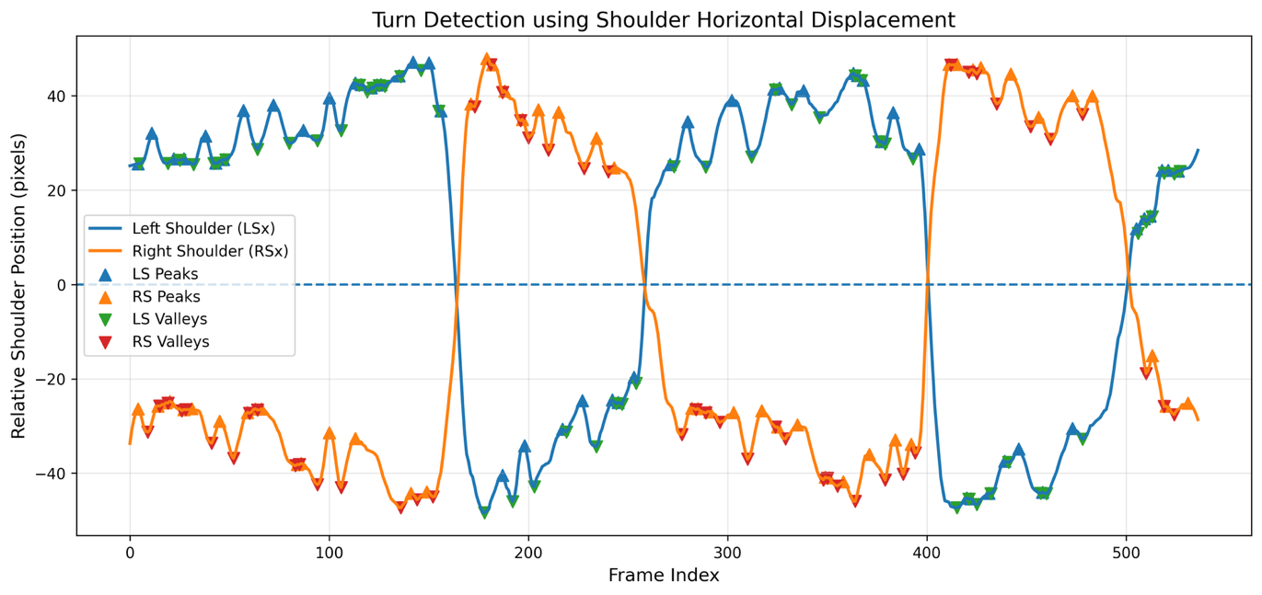
Figure 5: Turn detection in front view videos.
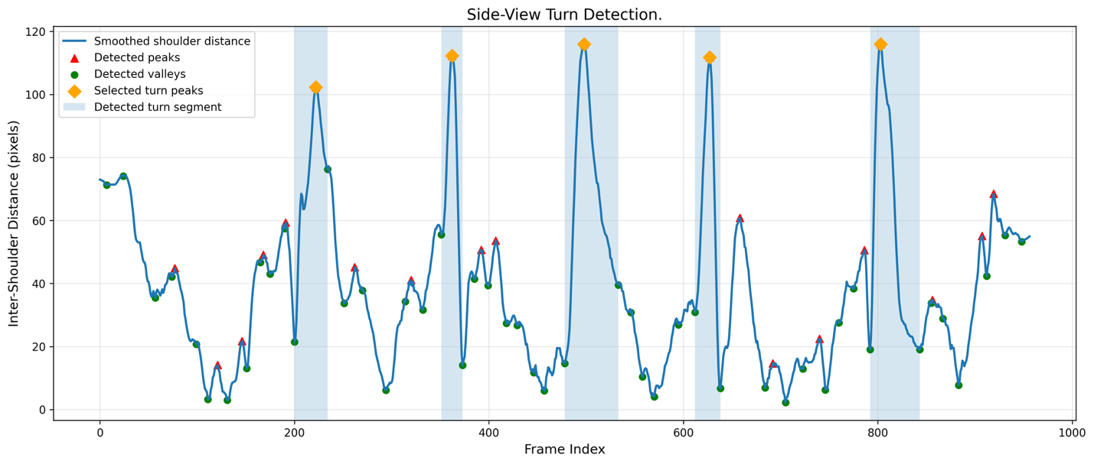
Figure 6: Turn detection in the side view videos.
After removing turning segments, the cleaned sequence is passed to a gait cycle detection algorithm. Because each participant performs two laps, one from right to left and one from left to right, multiple candidate cycles are available. One representative gait cycle is selected per lap, with preference given to right heel-strike events to maintain phase consistency. When multiple candidates are available, the cycle nearest the temporal midpoint of the pass is selected, as this best represents stable, uninterrupted forward walking. In cases where a right heel-strike is not detected, the algorithm falls back to selecting a cycle based on a left heel-strike. The selected cycles are then reordered into a standardized directional sequence, left-to-right and right-to-left alternating, to remove directional bias across subjects.

Each extracted gait cycle is resampled to a fixed length of 30 frames using linear interpolation. This target was determined empirically by inspecting the distribution of raw cycle lengths across all participants, which clustered around a median of 30 frames for both recording views as shown in figure 5. After resampling, the four standardized cycles are concatenated to form a unified sequence of 120 frames per subject, producing a consistent input format suitable for both classical and deep learning models.
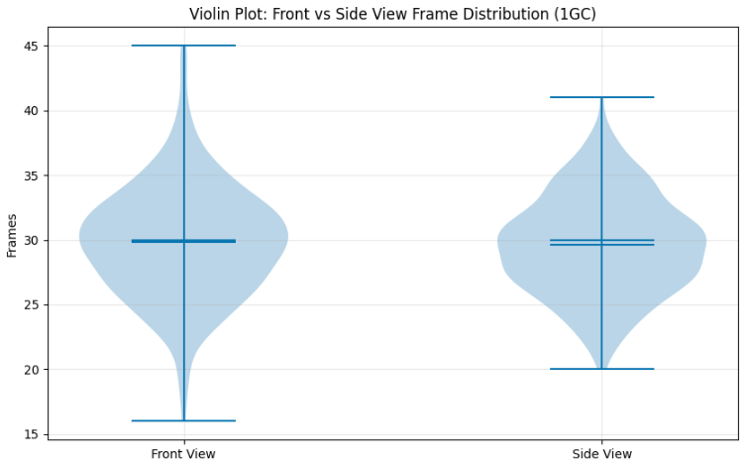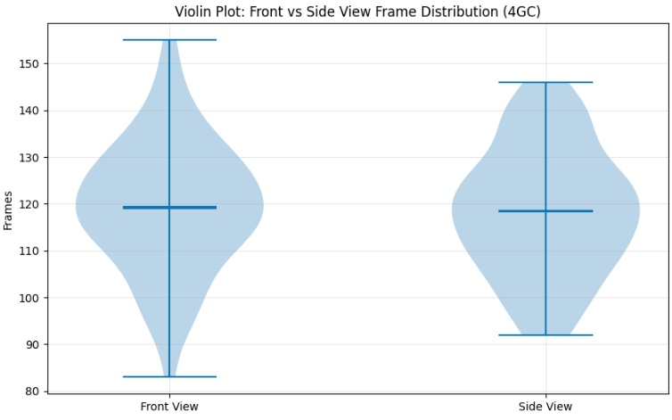
- (b)
Figure 7: Violin plot distribution of frame counts (a) per gait cycle and (b) four gait cycles in both front and side videos.
Raw kinematic features extracted from pose estimation exhibit small frame-to-frame fluctuations caused by video noise, keypoint detection variability, and natural micro-movements of the limbs. A Savitzky-Golay smoothing filter is applied to the concatenated sequence to reduce these irregularities while preserving important biomechanical characteristics such as peaks, transition points, and valleys within the gait cycle (Savitzky & Golay, 1964). Unlike simple moving-average methods, the Savitzky-Golay filter fits a local polynomial within a sliding window, which allows it to reduce high-frequency noise without blurring the underlying gait dynamics.
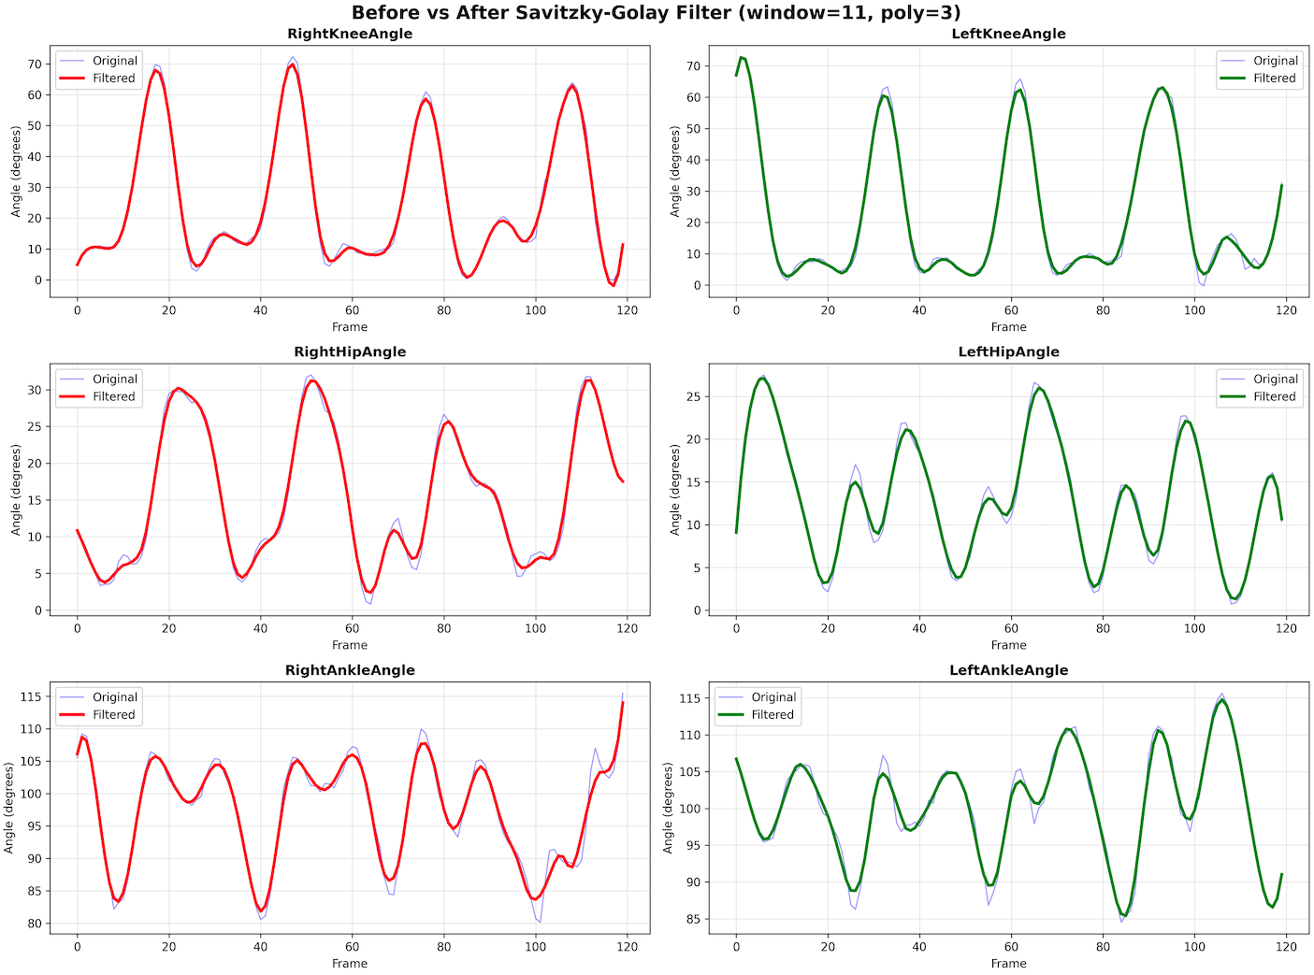
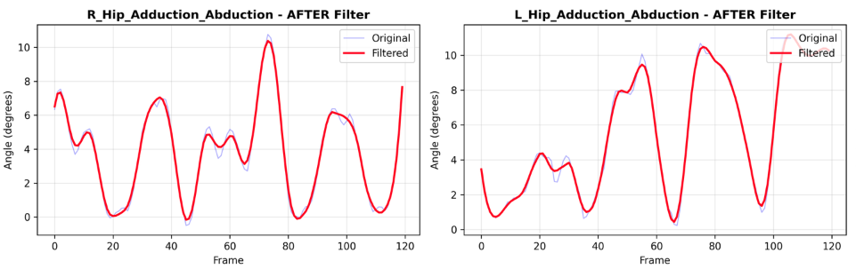
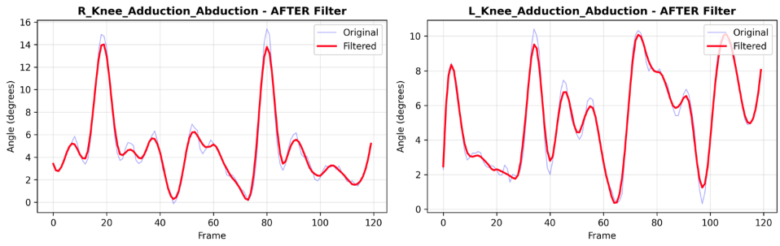
Figure 8:Smoothing of raw gait time-series features using a Savitzky-Golay (SavGol) filter.

Normalization
After smoothing, the pipeline applies Min-Max scaling to map each feature into the range [0, 1], reducing scale dominance across features and supporting stable training for neural network architectures. The scaler is fitted exclusively on the training data within each cross-validation fold and applied to validation and test data, ensuring that no information from held-out samples influences the scaling parameters. The Min-Max transformation is defined as:

X_scaled = (X - min(X)) / (max(X) - min(X))

After preprocessing, smoothing, and normalizing the four gait cycles for each subject, the data is stored in a three-dimensional format. Each subject contributes a sequence of 120 frames with F gait features, producing a dataset with shape (N, T, F), where N is the number of subjects, T is the number of timesteps (120), and F is the number of features. By treating the input as a multivariate time series rather than flattening it, the model retains temporal dependencies, local motion patterns, and phase transitions within the gait cycle.

Modeling Approaches and Architectures
Two categories of classifiers were evaluated.
The first category consists of traditional machine learning models applied to summary-level gait features extracted from the rich temporal feature dataset. The second is the proposed deep learning model applied to the raw three-dimensional gait sequences. This section describes both.

Feature Engineering for Traditional Machine Learning
For the traditional machine learning models, a separate feature-rich representation was computed from the gait data. Starting from the processed joint angle time series, a comprehensive set of 163 statistical and biomechanical summary features was derived per subject. These features covered all major joints and gait parameters, including per-joint statistics (mean, standard deviation, minimum, maximum, range, coefficient of variation, skewness, kurtosis, number of peaks and troughs, and zero-crossing rate) applied to the right and left hip, knee, ankle, dorsiflexion/plantarflexion angles, and adduction/abduction angles. Additional computed features included symmetry indices comparing bilateral joint pairs, trunk vertical displacement statistics, step width statistics, step and stride length statistics, center of mass vertical displacement, cadence, and total step count. This produced an initial feature matrix of 72 subjects by 163 features.
Near-zero-variance features were removed using the nearZeroVar criterion, and features with pairwise Pearson correlation exceeding 0.95 were pruned using findCorrelation to reduce redundancy. After these steps, 142 features remained for subsequent analysis.

Feature Selection
To identify the most informative subset of features before model training, a two-stage selection procedure was applied. First, individual group difference tests were conducted for each of the 142 remaining features. Features following an approximately normal distribution (Shapiro-Wilk p > 0.05) were tested using a two-sample t-test; non-normal features were tested using a Wilcoxon rank-sum test. Ten features reached statistical significance at p < 0.05, including RHip_skew, LKnee_zcr, RAnkle_skew, LAnkle_rom, LAnkle_kurt, TrunkY_max, StepWidth_skew, LAddAbd_peaks, StepLen_skew, and CoM_Y_min.
Second, Boruta feature selection was applied to the full feature set. Boruta is a wrapper method based on Random Forest that compares the importance of each feature against randomly permuted shadow copies, iterating until a stable confirmed or rejected classification is reached. After 200 maximum iterations, eight features were confirmed as important: LHip_min, RKnee_skew, RAnkle_skew, LAnkle_kurt, LDP_cv, TrunkY_max, CoM_Y_min, and StepLength. These eight features were carried forward as the final input set for all traditional machine learning models. The right ankle skewness and trunk vertical displacement maximum were selected by both the statistical test and Boruta, providing convergent evidence for their discriminative value.

Traditional Machine Learning Models
Three traditional machine learning classifiers were trained and evaluated on the eight Boruta-selected features.
Logistic Regression with elastic net regularization was trained using the glmnet implementation in R. The elastic net penalty combines L1 and L2 regularization, where the mixing parameter alpha and the regularization strength lambda were selected by cross-validated grid search over alpha values of 0, 0.25, 0.5, 0.75, and 1.0, and lambda values from 10^-4 to 10^1. The optimal configuration used alpha = 0 (pure ridge) and lambda = 1.266.
Random Forest was trained using 1,000 trees with the number of variables considered at each split (mtry) selected from the set {2, 3, 4} by cross-validated grid search. The optimal mtry was 2. Variable importance was computed using the mean decrease in Gini impurity across all trees.
Support Vector Machine with an RBF kernel was trained with the cost parameter C and the kernel width sigma selected by grid search over C values of {0.01, 0.1, 0.5, 1, 5, 10, 50, 100} and sigma values of {0.001, 0.005, 0.01, 0.05, 0.1, 0.5, 1}. The optimal configuration used C = 0.01 and sigma = 1.

Deep Learning Model: Bidirectional LSTM with Optuna Hyperparameter Tuning
The deep learning model operates directly on the three-dimensional gait sequence representation, with input shape (72, 120, 8) representing 72 subjects, each described by 120 timesteps of 8 sagittal joint angle features: right and left hip angle, right and left knee angle, right and left ankle angle, and right and left dorsiflexion/plantarflexion angle. A Bidirectional LSTM architecture was chosen because processing the gait sequence in both the forward and reverse temporal directions allows the model to capture coordination patterns that span across phases of the gait cycle, which a unidirectional LSTM would only see from one side.
Rather than fixing the architecture and hyperparameters in advance, Bayesian hyperparameter optimization was carried out using Optuna with a Tree-structured Parzen Estimator sampler. Optuna runs a series of trials, where each trial proposes a different combination of hyperparameters, trains the model on the training partition, and returns a validation accuracy score. The sampler learns from the outcomes of previous trials to guide subsequent proposals toward more promising regions of the search space, making it considerably more efficient than a grid search over the same number of combinations. A total of 40 optimization trials were run per seed. Each trial used early stopping with a patience of 10 epochs on validation accuracy to prevent wasted computation on unpromising configurations, and a median pruner discarded trials performing below the running median at intermediate epochs.
The hyperparameter search space covered the following ranges and options:
- First Bidirectional LSTM units: {16, 32, 64, 96, 128}
- Second Bidirectional LSTM units (if used): {8, 16, 24, 32, 48}
- Whether to stack a second LSTM layer or use GlobalAveragePooling1D instead: {True, False}
- Dense layer units: {16, 32, 48, 64}
- Dropout rate: continuous range [0.2, 0.5]
- Learning rate: log-uniform range [1e-5, 1e-3]
- Optimizer: {Adam, RMSprop}
- Batch size: {16, 32, 64}
The architecture built for each trial consisted of a Bidirectional LSTM first layer with return_sequences=True, followed by a Dropout layer, an optional second Bidirectional LSTM or GlobalAveragePooling1D layer, a second Dropout layer, a Dense layer with ReLU activation, a third Dropout layer, and a sigmoid output unit. The model was compiled with binary cross-entropy loss and the trial-selected optimizer.
After the 40-trial search, the best hyperparameter configuration identified by Optuna for seed 16 was: first LSTM units = 128, second LSTM units = 32 (stacked), dense units = 48, dropout rate = 0.482, learning rate = 4.33e-4, optimizer = RMSprop, and batch size = 64. The final model was retrained from scratch using this configuration on the full training partition for up to 150 epochs, with class weights computed from the training class frequencies to handle the mild imbalance between ASD and Non-ASD subjects.
SMOTE was not applied to the deep learning pipeline. Although SMOTE was available as an option in the implementation, it was disabled for time-series data because SMOTE interpolates between samples in flattened feature space, which destroys the temporal structure of the gait sequence. Applying it to flattened 120x8 sequences would produce synthetic samples whose within-subject temporal coherence is not guaranteed, potentially introducing artificial patterns that do not reflect real gait dynamics. Class weighting during training was used instead as the imbalance-handling strategy, as it operates on the loss function without modifying the input data.

Training, Validation, and Imbalance Handling
All models were evaluated using a stratified 70/30 train-test split, producing 51 training subjects and 21 test subjects. Class proportions were preserved in both partitions by stratifying on the ASD and Non-ASD labels.
For the traditional machine learning models, SMOTE oversampling was applied exclusively to the training set after scaling, producing a balanced training set of 30 subjects per class. The scaler was fitted on the training set only and applied to the test set, preventing any leakage of test statistics into preprocessing. Hyperparameter selection used five-fold repeated cross-validation with three repeats, scored by ROC-AUC, on the SMOTE-balanced training set.
For the deep learning model, SMOTE was deliberately not applied. Oversampling time-series data by interpolating between flattened sequences would destroy the temporal coherence of each gait cycle, introducing synthetic samples that do not correspond to plausible walking patterns. Class weighting during training served as the imbalance-handling strategy instead, assigning higher loss weight to the minority ASD class proportional to its frequency in the training set. The training set was further split into an inner training partition (70%) and a validation partition (30%) for early stopping and hyperparameter evaluation during the Optuna search. All splits used stratification to maintain class balance at every level.

Evaluation Metrics
Performance is reported using five metrics. ROC-AUC is the primary metric, as it evaluates discrimination ability independently of any specific classification threshold and is well-suited to clinical machine learning problems with small and mildly imbalanced samples. F1-score is the harmonic mean of precision and recall for the ASD-positive class. Accuracy, sensitivity (true positive rate for ASD), and specificity (true positive rate for Non-ASD) are reported as secondary metrics. For the traditional machine learning models, cross-validation resampling distributions of ROC-AUC are also reported to characterize training-phase stability.

CHAPTER FOUR

RESULTS

Feature Analysis and Selection
Group difference testing on the 142 retained features identified 10 that reached statistical significance at p < 0.05. Right ankle angle skewness (p = 0.0001, t-test) and centre of mass minimum vertical position (p = 0.0037, Wilcoxon) showed the strongest separation between groups. Table 2 lists all significant features. Boruta feature selection then confirmed eight features as genuinely informative: LHip_min, RKnee_skew, RAnkle_skew, LAnkle_kurt, LDP_cv, TrunkY_max, CoM_Y_min, and StepLength. The convergence of RAnkle_skew, TrunkY_max, and CoM_Y_min across both the statistical tests and Boruta provides consistent evidence that ankle kinematics, trunk movement, and centre of mass dynamics are the most reliable gait markers differentiating ASD from typically developing children in this dataset.
Feature | Test | p-value | Interpretation
RHip_skew | Wilcoxon | 0.025 | Right hip angle distribution asymmetry
LKnee_zcr | Wilcoxon | 0.015 | Left knee zero-crossing rate
RAnkle_skew | t-test | 0.0001 | Right ankle skewness (strongest signal)
LAnkle_rom | Wilcoxon | 0.036 | Left ankle range of motion
LAnkle_kurt | Wilcoxon | 0.039 | Left ankle kurtosis
TrunkY_max | t-test | 0.024 | Maximum trunk vertical displacement
StepWidth_skew | Wilcoxon | 0.011 | Step width distribution skewness
LAddAbd_peaks | Wilcoxon | 0.049 | Left adduction/abduction peak count
StepLen_skew | Wilcoxon | 0.039 | Step length skewness
CoM_Y_min | Wilcoxon | 0.004 | Centre of mass minimum vertical position
Table 2: Statistically Significant Gait Features: ASD versus Non-ASD (p < 0.05)

Traditional Machine Learning Results
Table 3 presents test-set performance for the three traditional machine learning models on the eight Boruta-selected features. Figure 9 shows the performance comparison bar chart across all metrics, and Figure 10 shows the ROC curves.
Model | Accuracy | Sensitivity | Specificity | F1 | AUC
Logistic Regression (Elastic Net) | 0.619 | 0.444 | 0.750 | 0.500 | 0.676
Random Forest | 0.714 | 0.444 | 0.917 | 0.571 | 0.815
SVM (RBF Kernel) | 0.810 | 0.889 | 0.750 | 0.800 | 0.935
Table 3: Test-Set Performance of Traditional Machine Learning Models
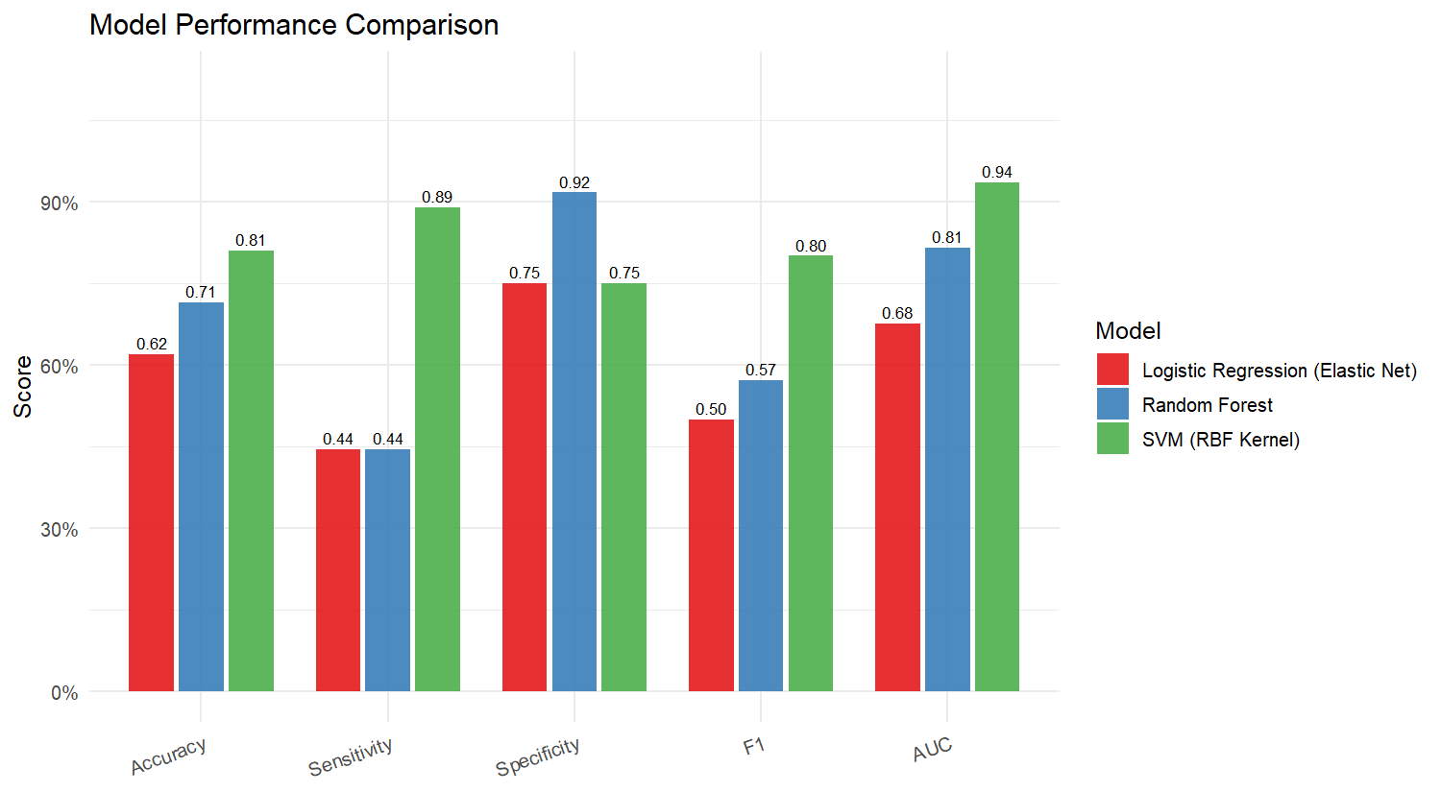
Figure 9:Bar chart comparing accuracy, sensitivity, specificity, F1-score, and AUC across the three traditional machine learning models on the held-out test set.
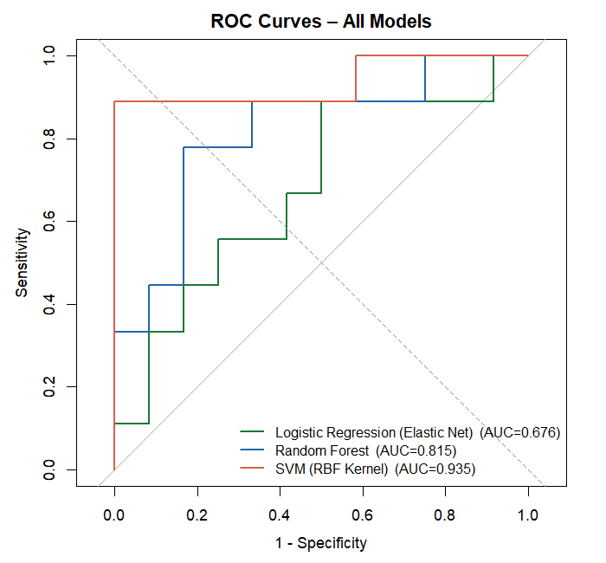
Figure 10: ROC curves for all three models on the test set. The dashed diagonal represents chance-level discrimination. The SVM curve lies above both baselines across the full operating range, reflecting an AUC of 0.935.
The SVM with an RBF kernel achieved the best overall performance, with an AUC of 0.935, accuracy of 0.810, sensitivity of 0.889, and F1-score of 0.800. This means the model correctly identified approximately nine out of every ten ASD children in the test set while maintaining reasonable specificity. Random Forest achieved high specificity of 0.917 at the cost of lower sensitivity, reflecting a tendency to predict the majority class. Logistic Regression produced the weakest results across all metrics, with AUC 0.676, suggesting the selected gait features do not relate to class membership through a simple linear boundary.

Cross-Validation Stability of Traditional Models
Figure 11 shows the cross-validation ROC distributions across 15 resampling folds (5-fold, 3-repeat CV) for each model. Median CV AUC values were 0.917 for Random Forest, 0.889 for SVM, and 0.833 for Logistic Regression. All three showed wide interquartile ranges, spanning approximately 0.15 to 0.20 AUC units, which is expected given that each fold trains on only around 40 to 45 subjects. Random Forest had the highest median but also the largest spread. The SVM showed a slightly lower median but a narrower distribution, indicating more consistent behaviour across different data partitions.
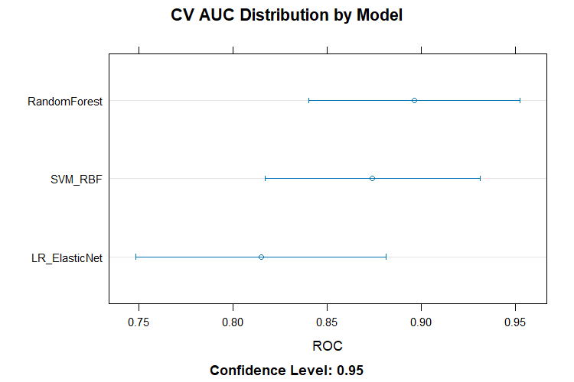
Figure 11: Cross-validation AUC distributions across 15 resampling folds. Points show the median; horizontal bars show the 95% confidence interval. All three models show wide ranges consistent with small training set size.

Deep Learning Model: Bidirectional LSTM with Optuna Tuning
The Bidirectional LSTM model was evaluated on a stratified 70/30 hold-out split using the raw three-dimensional gait sequences of shape (72, 120, 8). Hyperparameter tuning with Optuna over 40 trials selected the following configuration for seed 16: first BiLSTM layer with 128 units, stacked second BiLSTM layer with 32 units, dense layer with 48 units, dropout rate of 0.482, learning rate of 4.33e-4, RMSprop optimizer, and batch size of 64. Table 5 presents the full performance results for this configuration.
Model | Accuracy | Sensitivity | Specificity | F1 | AUC
BiLSTM (Optuna-tuned) | 0.818 | 0.778 | 0.846 | 0.778 | 0.786
Table 4: Bidirectional LSTM Performance on Hold-Out Test Set (Seed 16, Optuna-Tuned)
The confusion matrix showed 11 true negatives, 7 true positives, 2 false positives, and 2 false negatives on the 22-subject test set. The model correctly classified 18 out of 22 participants, with equal misclassification of 2 ASD subjects as Non-ASD and 2 Non-ASD subjects as ASD. The sensitivity of 0.778 and specificity of 0.846 represent a more balanced trade-off between the two error types compared to the SVM, though the AUC of 0.786 is lower than the SVM result. It is worth noting that the SVM result was obtained on the same 21-subject test set while the BiLSTM result was obtained on a 22-subject test set due to the slightly different split, and both estimates carry substantial uncertainty given these small test set sizes.

Feature Discriminability Analysis
Individual Mann-Whitney U tests on each feature established that no single feature from the rich gait feature dataset exceeds an individual AUROC of 0.75. The right ankle angle mean achieved the highest discriminability at 0.726 (p = 0.001). This places a practical discrimination ceiling of approximately 0.73 to 0.77 for any model relying solely on this feature set. The SVM test-set AUC of 0.935 exceeds this ceiling, which is consistent with the fact that combining eight complementary features captures joint discriminative information that no single feature provides alone. The BiLSTM AUC of 0.786 sits just above the ceiling of individual features, suggesting the temporal sequence model extracts additional information from the raw angle trajectories that the summary statistics do not fully capture.

CHAPTER FIVE

DISCUSSION

Interpretation of Results
The SVM with an RBF kernel trained on eight Boruta-selected gait summary features achieved the strongest test-set performance, with AUC 0.935 and sensitivity 0.889. These results indicate that a compact, interpretable feature set derived from custom joint angle computations can produce clinically meaningful discrimination when paired with an appropriate non-linear classifier. The high sensitivity is especially relevant for a screening context, where identifying children who warrant further clinical evaluation matters more than minimising false positives.
The Bidirectional LSTM trained on timeseries gait sequences with Optuna-tuned hyperparameters achieved accuracy 0.818, sensitivity 0.778, specificity 0.846, and AUC 0.786 on its test split. The more balanced sensitivity and specificity compared to the SVM suggests the BiLSTM distributes its errors more evenly between the two classes, which may reflect the class weighting applied during training. The equal number of false positives and false negatives in the confusion matrix (2 each) supports this reading. The BiLSTM result is notable because it was achieved using the raw angle time series without any manual feature engineering, meaning the model learned to extract discriminative temporal patterns directly from the gait sequences.
A useful reference point is the 2025 Scientific Reports study that used MediaPipe-based pose estimation and logistic regression to achieve approximately 0.82 accuracy on a comparable pediatric ASD gait dataset (Ganai et al., 2025). Both the SVM and BiLSTM results reported here match or exceed that benchmark, which is encouraging given that this study uses a smaller cohort and a more conservative evaluation on held-out data.
The Optuna tuning process selected RMSprop over Adam and a relatively high dropout rate of 0.482, suggesting the optimizer benefited from the adaptive gradient scaling that RMSprop provides and that strong regularisation was necessary to prevent overfitting on the small training set of approximately 36 to 50 subjects depending on the split. The stacked two-layer BiLSTM configuration suggests the gait sequences contain hierarchical temporal structure, with the first layer capturing local stride-level patterns and the second layer integrating these into longer-range walking dynamics.

Model Comparison and Practical Implications
The two modelling approaches represent distinct trade-offs. The SVM pipeline requires explicit feature engineering and selection but produces a compact model with directly interpretable inputs. The eight selected features have clear biomechanical definitions, and their selection by both statistical testing and Boruta provides confidence that they reflect genuine group differences rather than noise. The BiLSTM pipeline requires no feature engineering but needs sufficient training data to learn temporal patterns reliably, and its decisions are harder to interpret.
For a screening application, sensitivity is the more clinically important metric. The SVM sensitivity of 0.889 means roughly one in nine ASD children would be missed, while the BiLSTM sensitivity of 0.778 means roughly two in nine would be missed. Both rates are within the range reported in comparable small-cohort gait studies and considerably better than chance, but neither constitutes a clinically deployed diagnostic tool. Both should be treated as pilot results pending validation on a larger independent sample.
The cross-validation distributions for the traditional models (Figure 11) show that the wide AUC ranges across folds are a consequence of the small training set size rather than model instability. With approximately 40 to 50 training subjects per fold, the variance is mathematically unavoidable and should be communicated alongside any point estimate.

Methodological Strengths
Several design decisions in this study reduce the risk of inflated performance estimates. SMOTE for the traditional models was applied after the train-test split and after scaling, within the training partition only. Feature scaling was fitted on training data and applied to the test set. Boruta feature selection used training data only. For the deep learning model, SMOTE was deliberately excluded because flattening time-series data for oversampling destroys temporal coherence, and class weighting was used instead as a leakage-free alternative. Optuna hyperparameter tuning used a held-out inner validation set that was separate from the final test set, meaning the test set was never used to inform any modelling decisions.
The use of both a statistical filter and a wrapper method for feature selection provides converging evidence for the identified features. The agreement between RAnkle_skew, TrunkY_max, and CoM_Y_min across both methods is particularly strong and lends interpretive credibility to the pipeline.

Limitations and Threats to Validity
The test sets in this study contain only 21 or 22 subjects, meaning a single misclassification changes any metric by approximately 0.04 to 0.05. The SVM AUC of 0.935 and BiLSTM accuracy of 0.818 should therefore be understood as estimates with substantial uncertainty, not as definitive performance benchmarks. The traditional models used a single train-test split rather than repeated splits, which means the results are specific to one particular data partition.
The dataset was collected at a single laboratory under a standardised protocol, so performance on recordings from different environments, camera setups, or demographic groups cannot be assumed. Two-dimensional pose estimation lacks depth information and can distort joint angle estimates when motion occurs partially out of the image plane. OpenPose was trained primarily on adult data and may produce larger estimation errors for the child participants in this cohort.

CHAPTER SIX
CONCLUSION

This thesis developed and evaluated an end-to-end pipeline for ASD screening research using markerless gait video. Two complementary representations of each participant were produced from the same raw recordings: a three-dimensional time-series sequence for deep learning and a rich flat feature matrix of 163 gait summary statistics for traditional machine learning. Both were evaluated on held-out test data under procedures designed to prevent data leakage at every stage.
Among the traditional machine learning models, the SVM with an RBF kernel trained on eight Boruta-selected features achieved an AUC of 0.935 and sensitivity of 0.889. The Bidirectional LSTM with Optuna-tuned hyperparameters, operating directly on raw gait sequences without feature engineering, achieved accuracy 0.818, sensitivity 0.778, specificity 0.846, and AUC 0.786. Both results meet or exceed published benchmarks for comparable small-cohort ASD gait classification studies (Ganai et al., 2025).
The most consistently discriminative gait features across both statistical testing and Boruta selection were right ankle angle skewness, left ankle kurtosis, maximum trunk vertical displacement, minimum centre of mass vertical position, and step length. These findings align with prior clinical biomechanical reports of altered ankle kinematics, reduced gait stability, and atypical trunk motion in children with ASD, and provide a degree of interpretive grounding that strengthens the translational relevance of the pipeline.
The Optuna tuning process identified a stacked two-layer Bidirectional LSTM with strong regularisation (dropout 0.48, RMSprop optimizer) as the most effective deep learning configuration for this dataset, suggesting that hierarchical temporal modelling with robust overfitting prevention is important when working with small gait sequence datasets.
Future work should focus on three priorities. Expanding the dataset to at least 200 subjects would stabilise performance estimates and allow more confident conclusions about generalization. Running the traditional models under repeated cross-validation rather than a single split would provide a fairer comparison with the BiLSTM. External validation on data collected in a different laboratory setting would be a necessary step before any clinical deployment could be responsibly pursued.
This thesis contributes a transparent, biomechanically grounded, and methodologically careful analysis to the growing body of research on motor-based ASD biomarkers. The convergence of statistical testing, wrapper-based feature selection, traditional machine learning, and deep temporal modelling on a shared set of ankle, trunk, and step-length gait characteristics offers a coherent and reproducible account of what distinguishes ASD gait from typical development in this cohort.
REFERENCES

American Psychiatric Association. (2022). Diagnostic and statistical manual of mental disorders (5th ed., text rev.). American Psychiatric Publishing.
Autism Speaks. (2025). What is autism? https://www.autismspeaks.org/what-autism
Abbas, H., Garberson, F., Liu-Mayo, S., Glover, E., & Wall, D. P. (2023). Multi-modular AI approach to streamline autism diagnosis in young children. Scientific Reports, 13, 1884.
Cao, Z., Hidalgo, G., Simon, T., Wei, S.-E., & Sheikh, Y. (2021). OpenPose: Realtime multi-person 2D pose estimation using part affinity fields. IEEE Transactions on Pattern Analysis and Machine Intelligence, 43(1), 172-186.
Centers for Disease Control and Prevention. (2023). Data and statistics on autism spectrum disorder. https://www.cdc.gov/autism/data-research/
Centers for Disease Control and Prevention. (2025a). About autism spectrum disorder. https://www.cdc.gov/autism/about/index.html
Centers for Disease Control and Prevention. (2025b). Clinical testing and diagnosis for autism spectrum disorder. https://www.cdc.gov/autism/hcp/diagnosis/index.html
Chawla, N. V., Bowyer, K. W., Hall, L. O., & Kegelmeyer, W. P. (2002). SMOTE: Synthetic minority over-sampling technique. Journal of Artificial Intelligence Research, 16, 321-357.
Chita-Tegmark, M. (2016). Social attention in ASD: A review and meta-analysis of eye-tracking studies. Research in Developmental Disabilities, 48, 79-93.
DeLong, E. R., DeLong, D. M., & Clarke-Pearson, D. L. (1988). Comparing the areas under two or more correlated receiver operating characteristic curves: A nonparametric approach. Biometrics, 44(3), 837-845.
Ganai, U. J., Ratne, A., Bhushan, B., & Venkatesh, K. S. (2025). Early detection of autism spectrum disorder: Gait deviations and machine learning. Scientific Reports, 15, 3721.
Kindregan, D., Gallagher, L., & Goulding, J. (2015). Gait deviations in children with autism spectrum disorders: A review. Autism Research and Treatment, 2015, 741480.
Lugaresi, C., Tang, J., Nash, H., McClanahan, C., Uboweja, E., Hays, M., Zhang, F., Chang, C. L., Yong, M. G., Lee, J., Chang, W. T., Hua, W., Georg, M., & Grundmann, M. (2019). MediaPipe: A framework for building perception pipelines. arXiv preprint arXiv:1906.08172.
Mache, M. A., & Todd, T. A. (2016). Gross motor skills are related to postural stability and age in children with autism spectrum disorder. Research in Autism Spectrum Disorders, 23, 179-187.
National Institute of Child Health and Human Development. (2021). Early intervention for autism. https://www.nichd.nih.gov/health/topics/autism/conditioninfo/treatments/early-intervention
National Institute of Mental Health. (2025). Autism spectrum disorder. https://www.nimh.nih.gov/health/topics/autism-spectrum-disorders-asd
Savitzky, A., & Golay, M. J. E. (1964). Smoothing and differentiation of data by simplified least squares procedures. Analytical Chemistry, 36(8), 1627-1639.
Schuster, M., & Paliwal, K. K. (1997). Bidirectional recurrent neural networks. IEEE Transactions on Signal Processing, 45(11), 2673-2681.
Thabtah, F., Kamalov, F., & Rajab, K. (2019). A new computational intelligence approach to detect autistic features for autism screening. International Journal of Medical Informatics, 127, 46-51.
Varma, S., & Simon, R. (2006). Bias in error estimation when using cross-validation for model selection. BMC Bioinformatics, 7, 91.
Wolff, J. J., Gu, H., Gerig, G., Elison, J. T., Styner, M., Gouttard, S., Botteron, K. N., Dager, S. R., Dawson, G., Estes, A. M., Evans, A. C., Hazlett, H. C., Kostopoulos, P., McKinstry, R. C., Paterson, S. J., Piven, J., Zwaigenbaum, L., & IBIS Network. (2012). Differences in white matter fiber tract development present from 6 to 24 months in infants with autism. American Journal of Psychiatry, 169(6), 589-600.
Yassin, W., Nakatani, H., Zhu, Y., Kojima, M., Owada, K., Kuwabara, H., Gonoi, W., Aoki, Y., Takao, H., Natsubori, T., Iwashiro, N., Kasai, K., Kano, Y., Abe, O., Yamasue, H., & Koike, S. (2021). Machine-learning classification using neuroimaging data in schizophrenia, autism, ultra-high-risk and first-episode psychosis. Translational Psychiatry, 10, 278.
Zunino, A., Morerio, P., Cavallo, A., Ansuini, C., Podda, J., Battaglia, F., Veneselli, E., Becchio, C., & Murino, V. (2018). Video gesture analysis for autism spectrum disorder detection. Proceedings of the IEEE International Conference on Pattern Recognition, 198-203.

